Software Documentation

Accounting Software

1st Update

**Team Members** – Pasan Malinda ,Harindu Kawsara ,SAmeera Ishan

**Start Date** -20/02/2018

**End Date** - 26/04/2018

2nd Update

**Team Members** – Pasan Malinda ,Thilini Hansika

**Start Date** -20/07/2018

**End Date** - 20/08/2018

**Language** –java ,jasper

**Tools** – netbeans ,iReoprt

Pasan Malinda – Business Analyzing , Ui design ,Database design ,System development , Testing , Installation , introduce to user .

Sameera Ishan –Ui Design

Harindu Kawsara –Reports & Invoice Designing

Thilinin Hansika –Ui Designing

**Introduction**

A high proportion of software process costs is incurred in producing this documentation. Furthermore, documentation errors and omissions can lead to errors by end-users and consequent system failures with their associated costs and disruption.

The documents associated with a software project and the system being developed have a number of associated requirements:

* Manage Accounts .
* Manage Customers .
* Make Payments .
* Make Sales .
* Manage Vendors .
* Pay Bills .
* Transfer Money .
* Get Reports .
* Manage Items .
* Purchase Order .
* Make Journal..
* Petty Cash.
* Back up Business Details .
* Write Cheques .

Satisfying these requirements requires different type of Document from informal working document through to professionally produced user manuals. Software Engineers are usually responsible for producing most of this documentation Although professional technical writers may assist with the final polishing of externally released information .

My Goals here are to describe the documentation which may be produced during the software process , to give some hints on ways of writing effective documents and to describe process involved in producing these documents . I Start by discussing different type of documentation. That may be produced in a software project . I then cover the important topic of document quality and discuss document structure , document standards and effective writing style finally , I cover process of preparing ,producing and managing documents .

**Software Process Documentation**

Effective management requires the process being managed to be visible. Because software is intangible and the software process involves apparently similar cognitive tasks rather than obviously different physical tasks, the only way this visibility can be achieved is through the use of process documentation .

1. Plans, estimates and schedules -: These are documents produced by managers which are used to predict and to control the software process.

2. Reports -: These are documents which report how resources were used during the process of development.

3. Standards -: These are documents which set out how the process is to be implemented. These may be developed from organizational, national or international standards.

**Requirement & Designing Documentation**

* **Login**

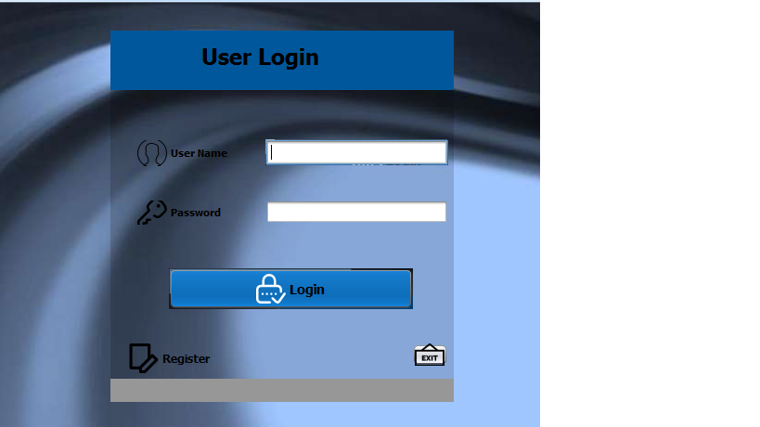

* This is the first page of this project .
* Only Accountant (User) ,Store Keeper or Admin can log in to the System .
* Security method applied this page .
* If Accountant ,Store Keeper or Admin login to the system Always check User Name and password by system .
* If not equals user Name or Passwords with System user Name and passwords ,can not login to the System.
* User can exit login whenever .
* If You are not registered , User can register after click register option .
* **Register**

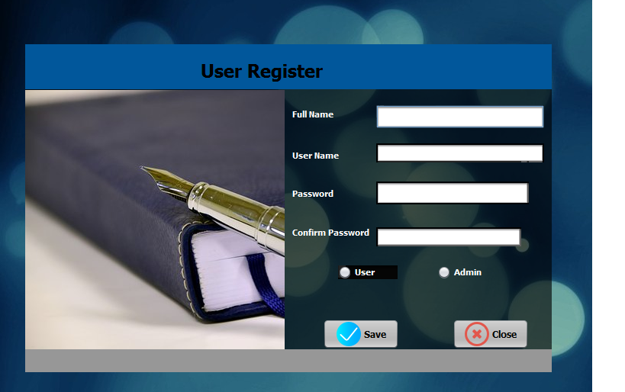

* This is User Registration .
* User can register with System after fill this text fields and finally click save button .
* User Can exit registration , after click close button .
* User should select their type . it is essential .
* If you escape this fields you can not register and log with this system .
* **Main Dashboard**

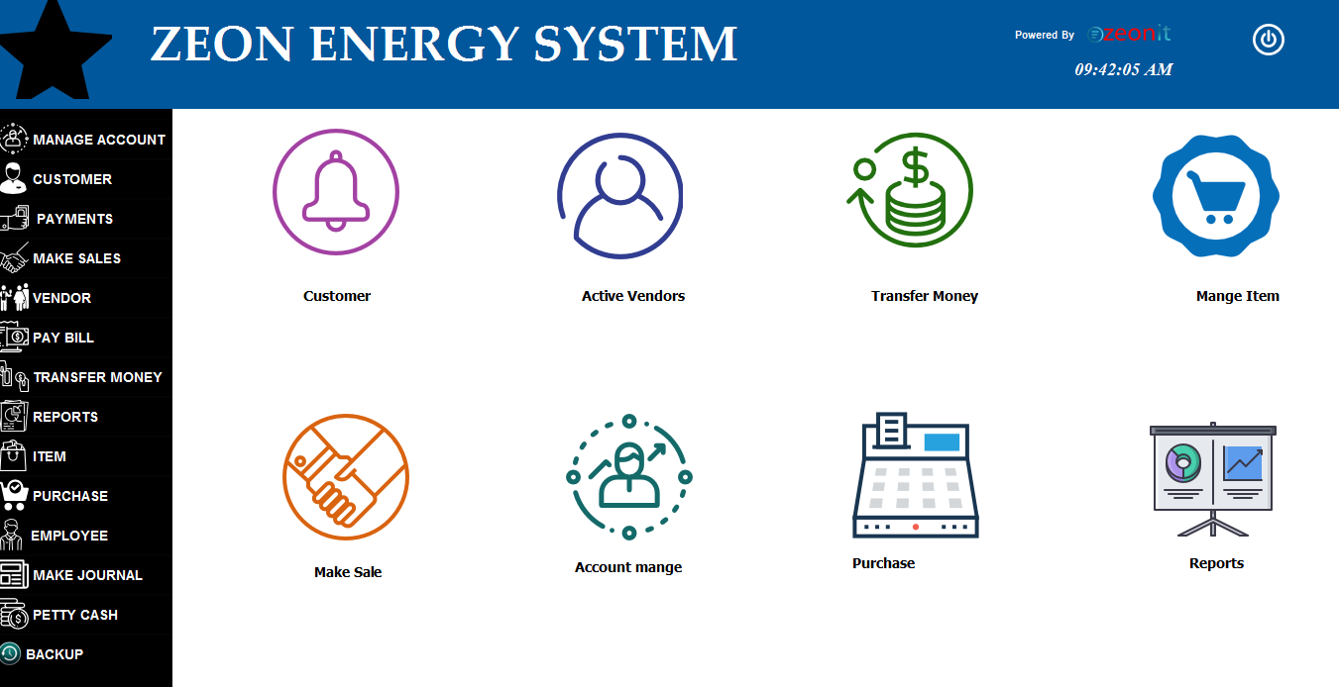

* This is the main user Component of this software .
* Other user Interfaces can be only Handled by this interface .
* The other interfaces can be loaded into this interface .
* If the new user handle this software the user can identify about the other interfaces because the interfaces are described .
* **Mange Accounts**

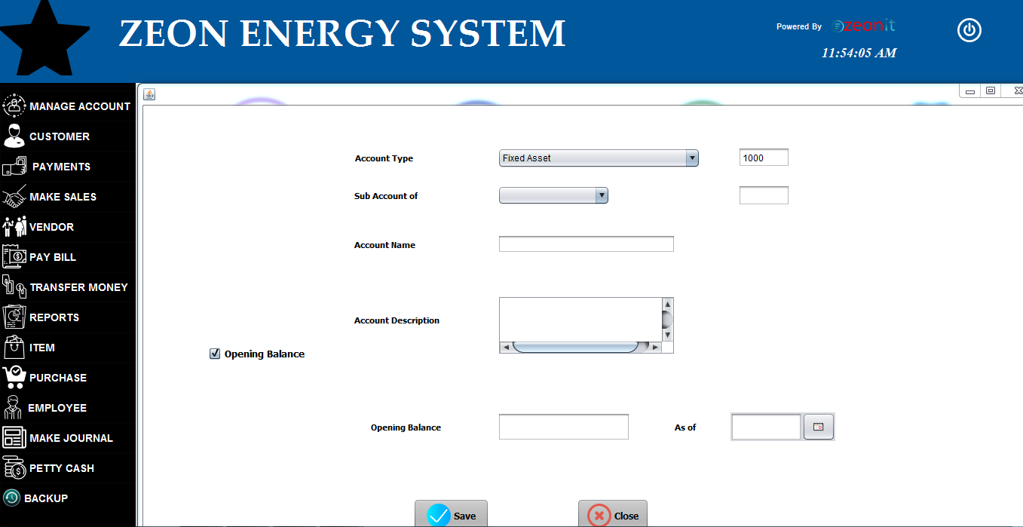

* This Is manage Account Interface .
* Firstly Accountant , Store Keeper or Admin should select account type in this combo box .
* If Customer has sub Account it also should be select .
* Unless Customer has not a Sub Account , no need to fill it .
* After that user need fill other text fields .
* If user mark the radio button , date and opening balance text field will auto enable .
* User need include to Account name text field to customer’s main Objective .
* User should include about customer’s objective description in account description text field .
* After that user should include customer’s account’s opening balance and current date .
* After fill All details user should click the save button .
* If user need cancel this ,click the close button .
* **Customer**

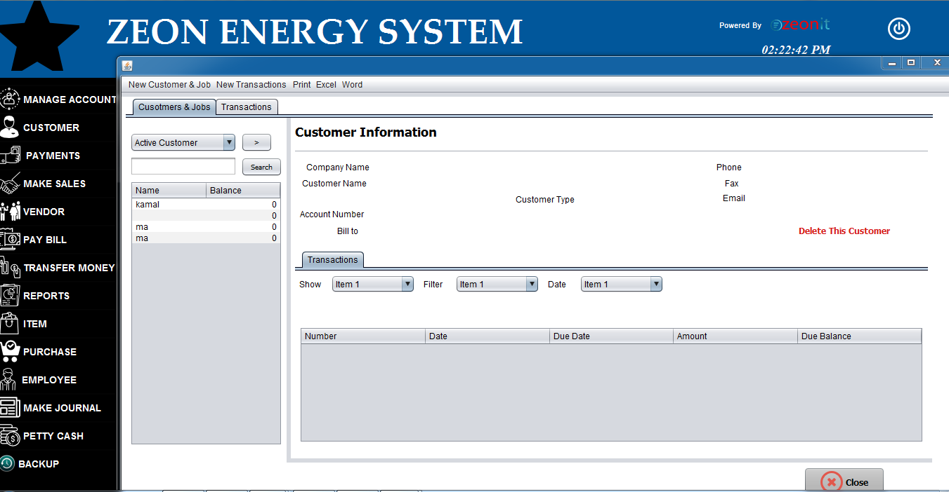

* This is the main user interface , handle all customers .
* User can search about invoices about this user interface .
* User can get a summery about this user interface .
* This invoices summery default enable with Customer & jobs label.
* Transaction label default enable with below form .

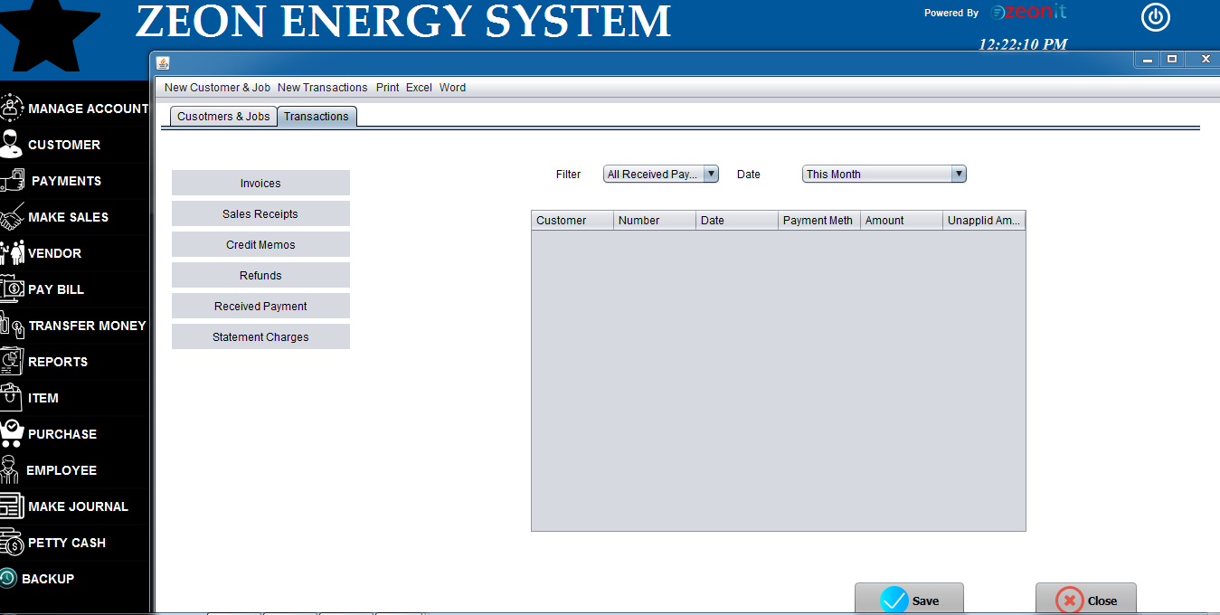

* Use can get summery about transaction in this form .
* If the user need make an new invoice click the new Customer & job .

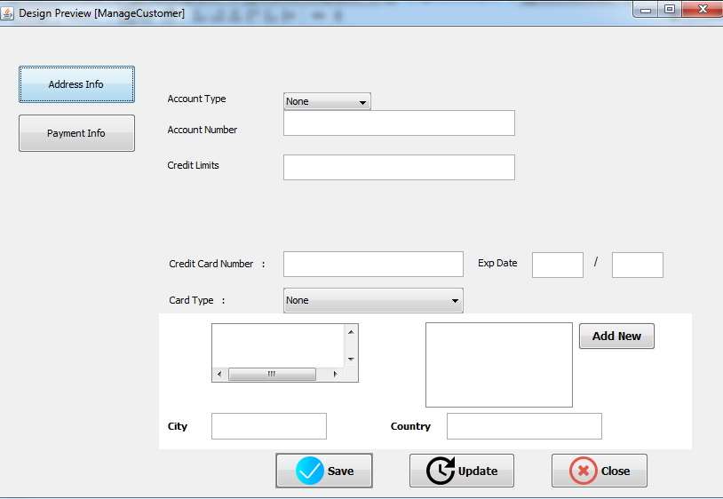

* After click new Customer & job get above user interface ..
* This form default enable with Address Info Button .
* Customer’s invoices details include in this form.
* If User entered incorrect Customer’s invoice details in to system ,user Can update it after click Update Button & enter correct details in to system.
* User can exit this form after click close button .
* After Click Payment Info button get new form we can see it below page .

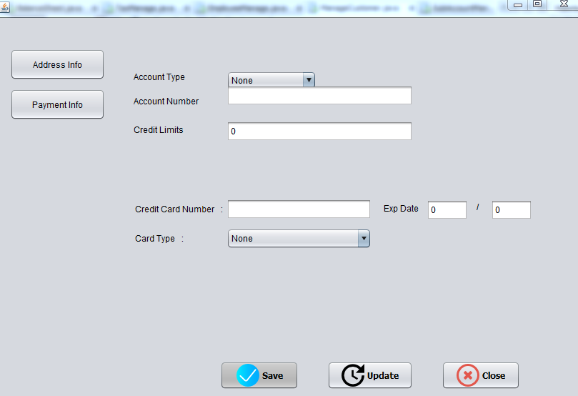

* Invoice’s payments details include this form .
* Firstly user need to select customer’s Account type .(ex-:SAMPATH ,BANK OF CEYLON,PEOPLES and etc…).
* If User input correct details in to system , click the save button . unless input correct details and afterthat click update button and input correct details in to the system.
* **Payments**

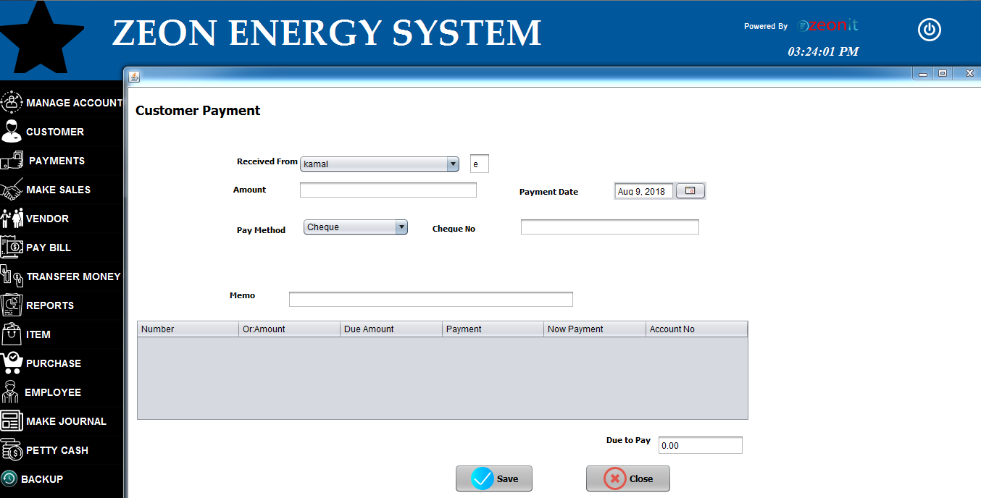

* This is Customer payments form .
* loading all invoice's appropriate customers in to Received from combo box .
* If User select the customer in combo box , auto loading all details to the table.
* If the customer has to payment to the appropriate invoice , user should include customer's new payments into the system .
* After payments , should reduce the payments amount invoice’s value. It is auto calculate by system.
* after the payments click the save button . afterthat new data update the database by the system .
* Customer can pay amount periodically as this method .
* **Make Sale**

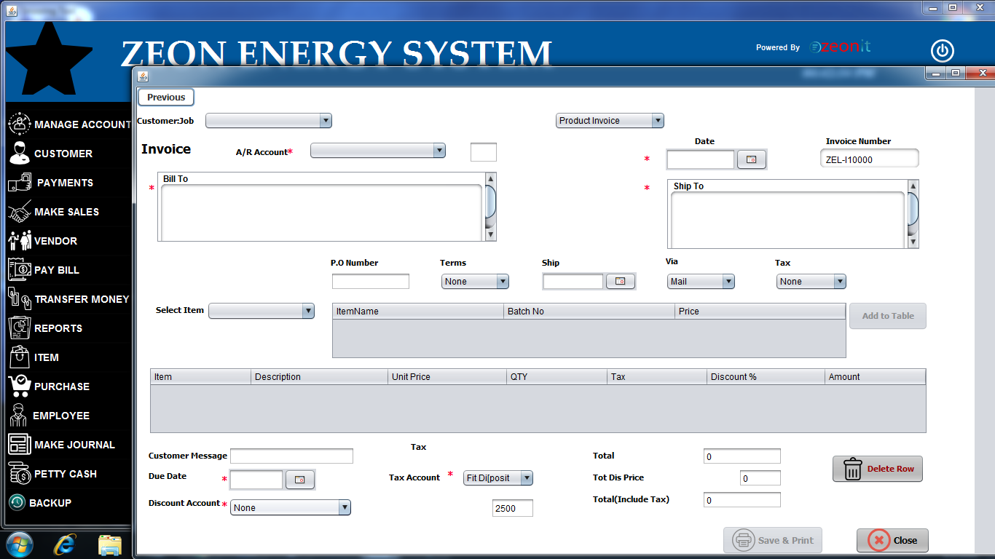

* This is the customer invoice .
* Firstly user should select customer job in above combo box .
* Afterthat include details correctly in to the text fields .
* Select the correct A/R Account in to the combo box .
* User should include the data customer’s wish .
* User Should enter correct date into the system .
* If user need to cancel or delete items , click the delete row button .
* Finally entered Customer’s detail , click the Save & print Button afterthat customer can get a bill about the invoice .
* User can exit this form whenever click the close button .
* **Vendor**

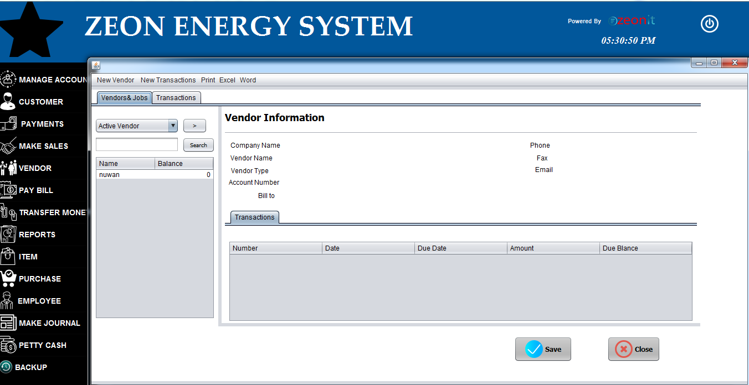

* This form As Customer form .
* This is the main user interface , handle all vendors .
* User can search about invoices about this vendor form.
* User can get a summery about this vendor invoices .
* This invoices summery default enable with Vendor & jobs label.
* Transaction label default enable with below form .

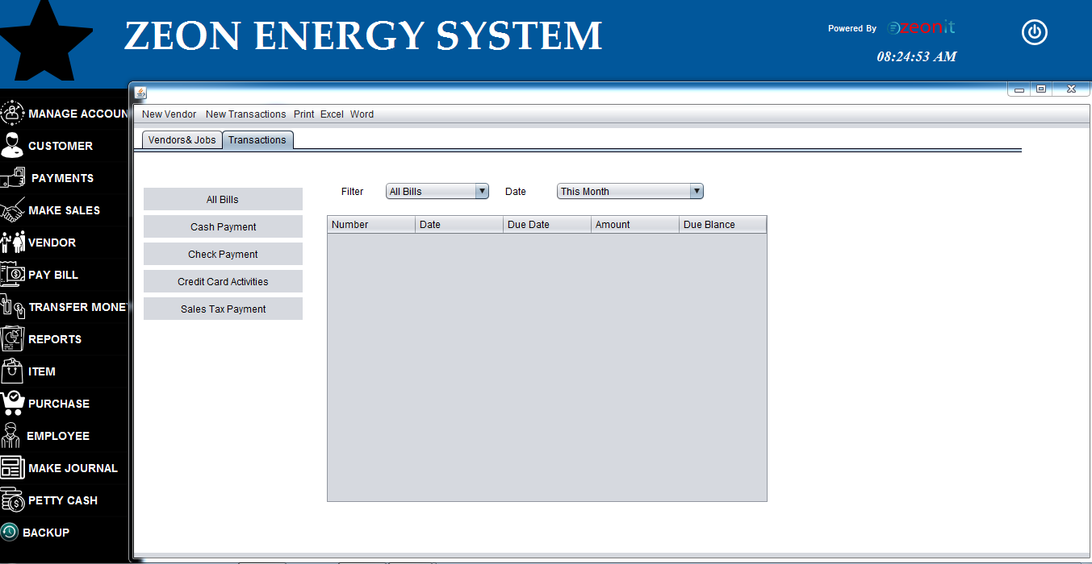

* User Can get Summery about the transactions.
* User can search about the transactions , using above combo box 's values.
* Using this form, the user can get detail about the bill payments summary ,Cash payments summary ,Check Payments summary , Credit card activities summary and Safety tax payments summary .
* If customer need to make an invoice , click the new vendor button .

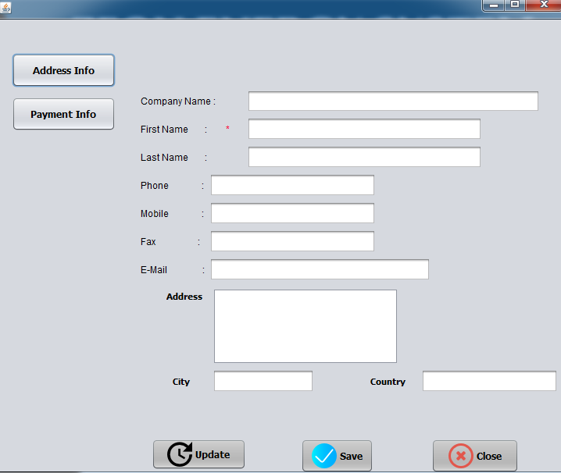

* User should fill about the Customer’s detail in this form .
* This for enable with address info button .
* Payment info button enable with blow form .

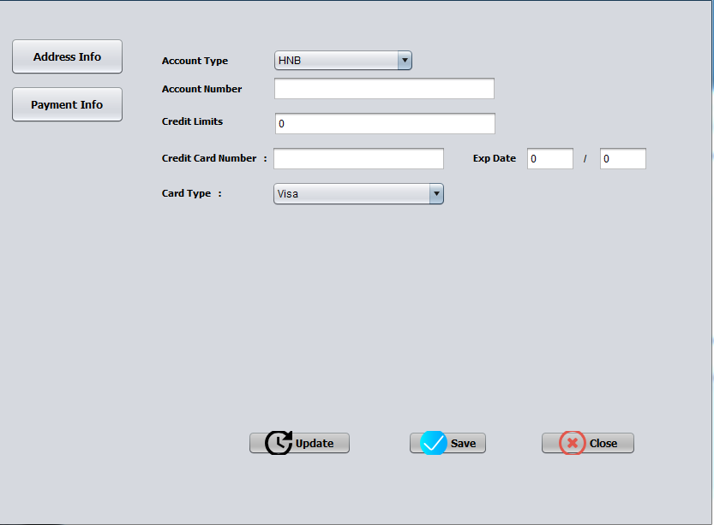

* This is the payment form about the customer invoice .
* After fill all blanks , use should click the save button .
* If user entered incorrect detail , user should get update option .
* You can exit this form click the close button .
* **Pay Bill**

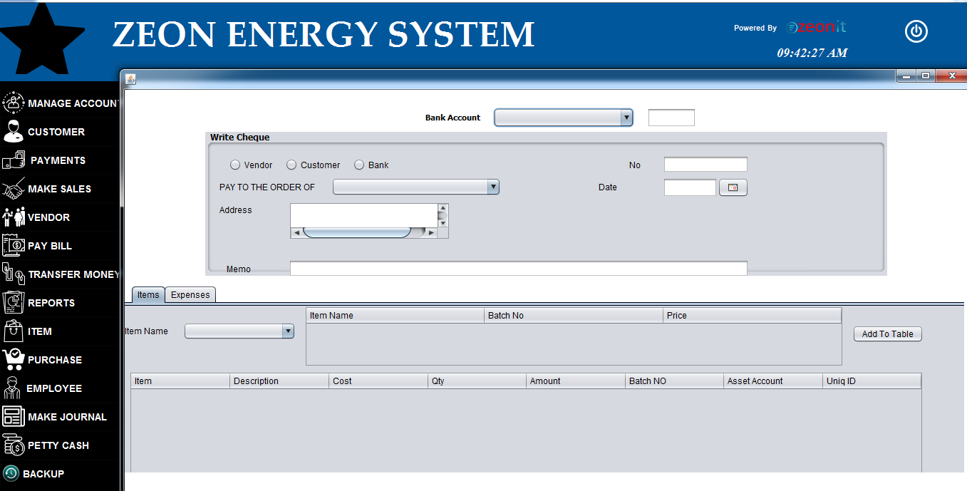

* This form use for pay for company’s bill .
* Firstly user should select type of vendors in write cheque panel .
* Secondly add check details correctly .
* Afterthat select items label . it is auto enable with below panel .
* User should select items , appropriate for above person’s cheque detail .
* After click the Expenses label you can get below form .

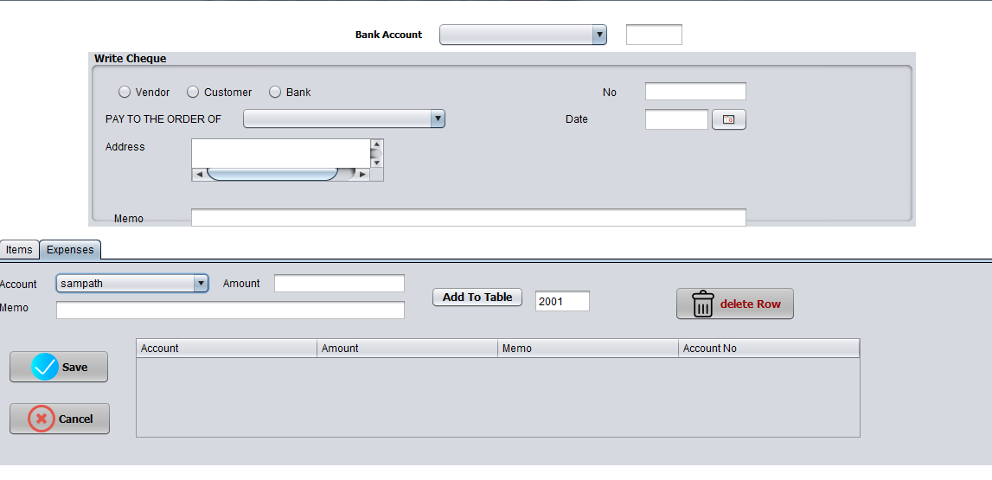

* This is item’s expenses form .
* User should enter correct details for item’s payments .
* If user entered incorrect details for system , please select & delete row in this table .
* User can close this form click the cancel button .
* **Transfer Money**

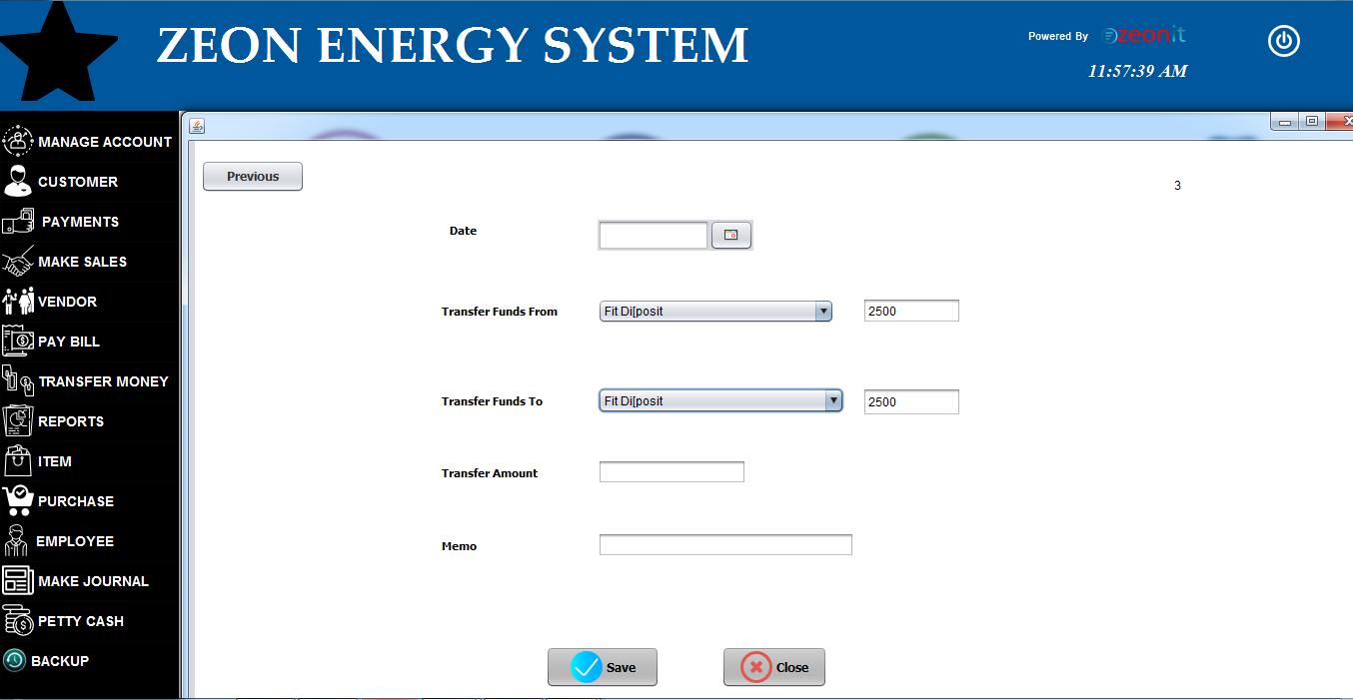

* This is transfer money user interface
* We can transfer money since one account to another account .
* Firstly select transfer date and select accounts correctly .
* Afterthat enter transfer amount and memo .
* Afaterthat user should click the save button .
* Calculate all functionalities by system .
* If user entered detail was incorrect , please click previous button .
* You can get below form .

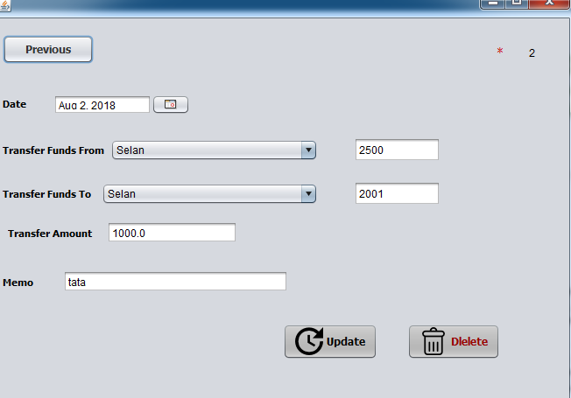

* System will auto loading data for previous transaction .
* User should update incorrect detail and later click the update button .
* If you need delete this transaction , please click delete button .
* **Manage Items**

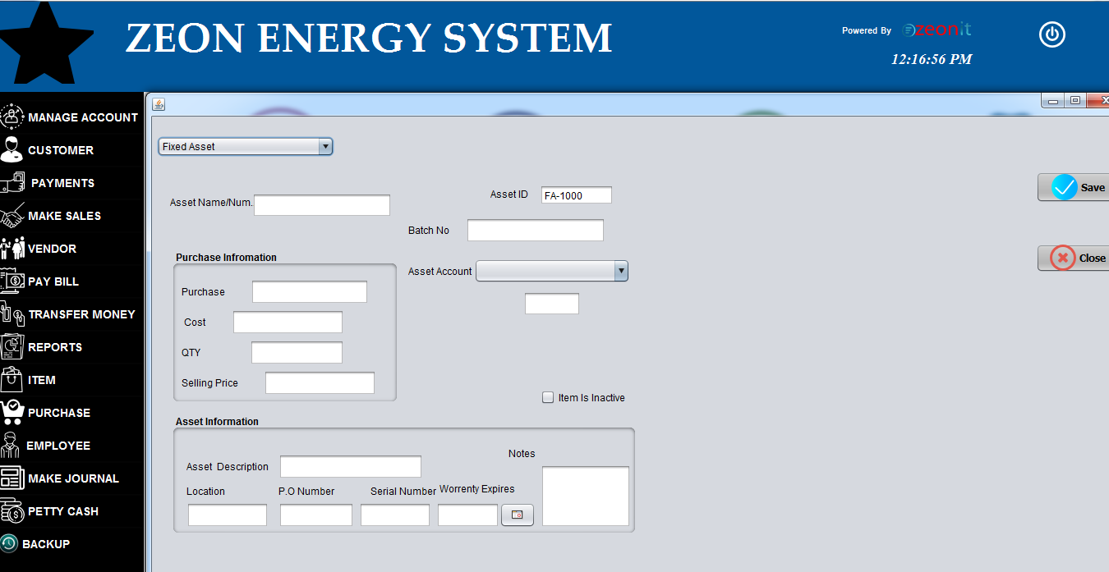

* This form auto enable with fixed asset .you can see it scroll down the combo box .
* Firstly enter asset name or number .
* After that enter purchase information in allocated panel .
* Asset information should enter below panel .
* If details are correct , click the save button .
* User can select Inventory items option above combo box & it is also auto enable with below form .

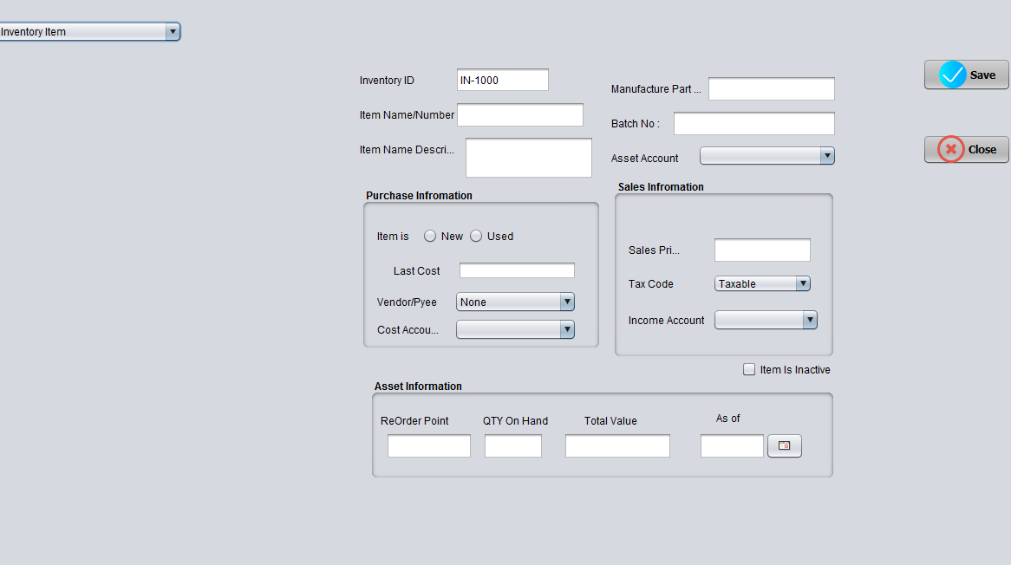

* Inventory id auto load by the system .
* Afaterthat enter about the detail of items .
* Purchase information and sales information should be include in appropriate panels .
* Later add Asset Information in below panel .
* At least click the save button .
* You can close this form whenever click the close button .
* **Purchase**

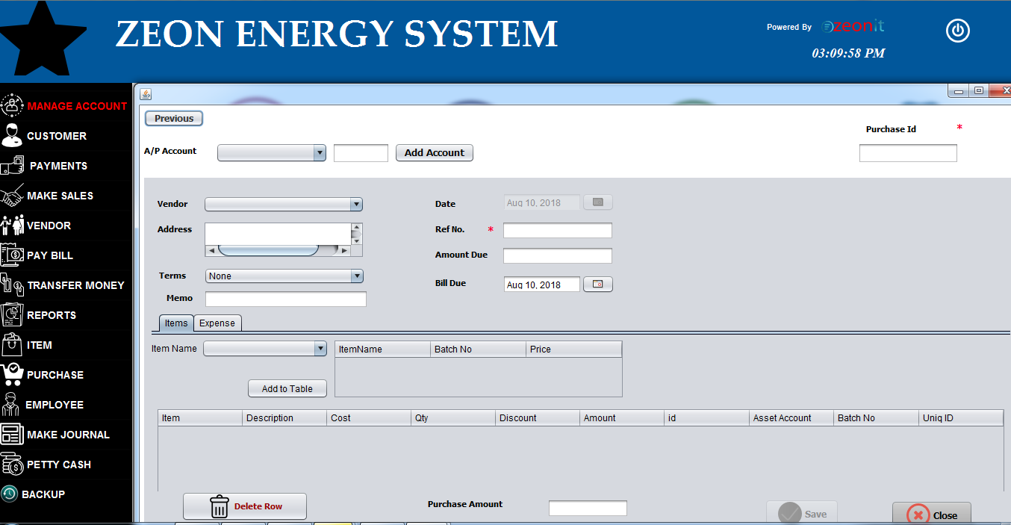

* a/p account auto load by system .
* vendor list also auto load to combo box .
* Items label default enable with below panel .
* Expenses label enable with below form .
* 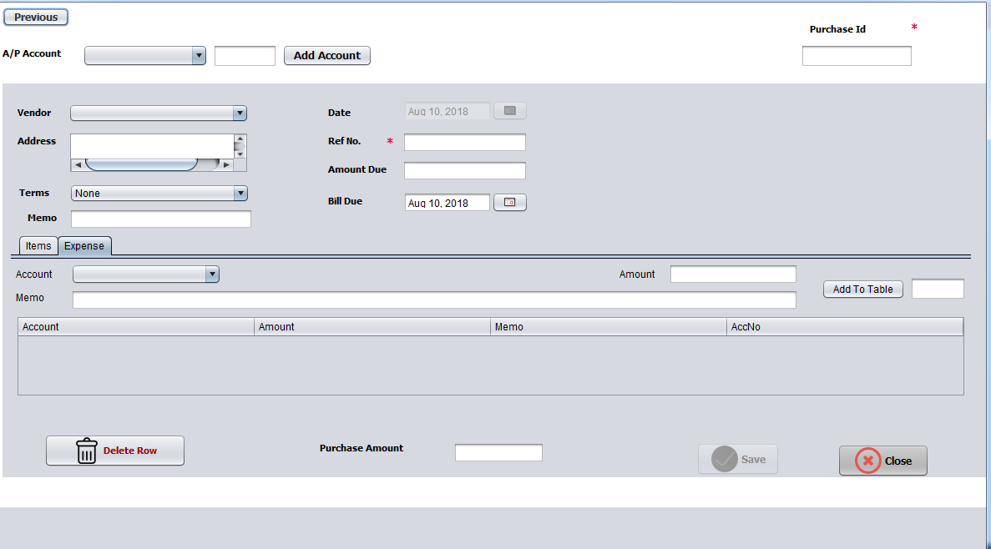enter detail in expense panel appropriate for about purchase .
* Afterthat click save button .
* If you entered incorrect data , please select & delete selected row in the table .
* user can add new account click the Add Account button .
* if user fill all blanks , auto enable save button .
* Afterthat we can see below form .

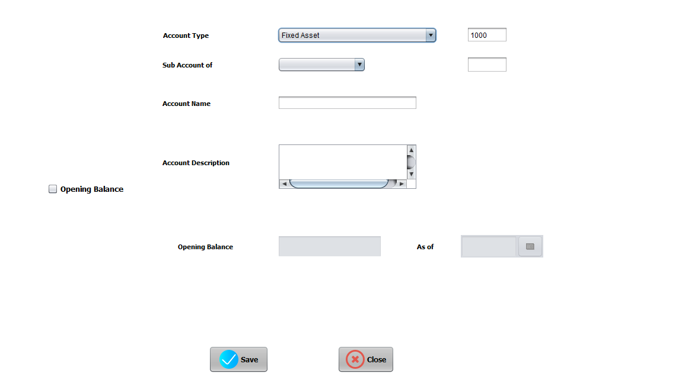

* Firstly select account type in Account type combo box .
* If that selected account type has sub accounts , it will auto load by system .
* If you mark the opening balance check box , opening balance text field and as of date as will auto enable .
* After enter all detail click the save button. If you need close this page , please click the close button .
* **Employee**

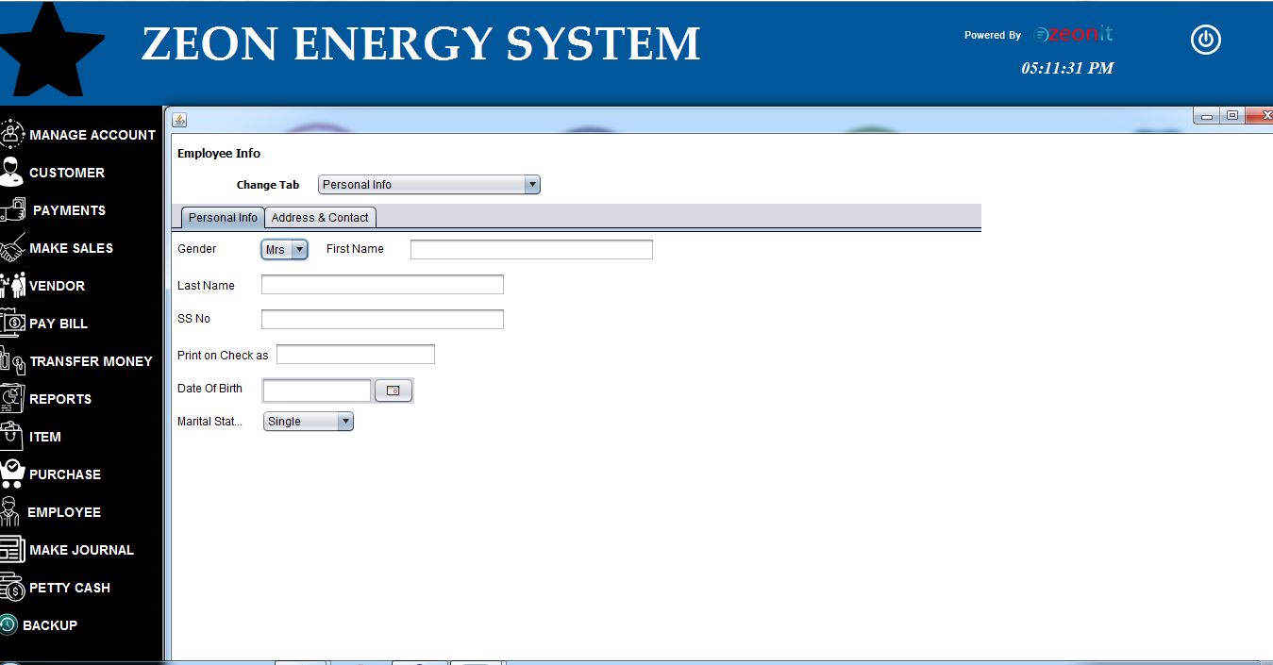

* Firstly user should enter the employee details in this blanks .
* Personal info auto enable with this form .
* Afterthat user should enter the Address & Contact details .

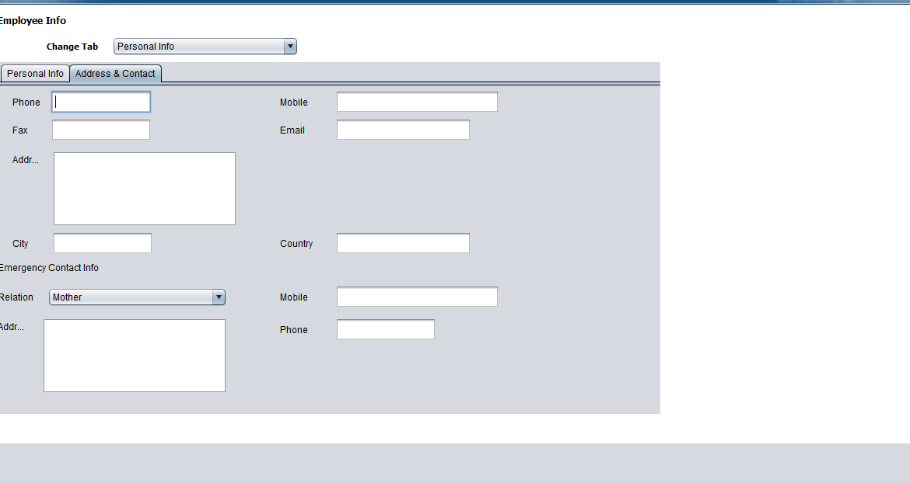

* This is Address & Contact form of employee .
* User should enter about employee’s address & contact details here .

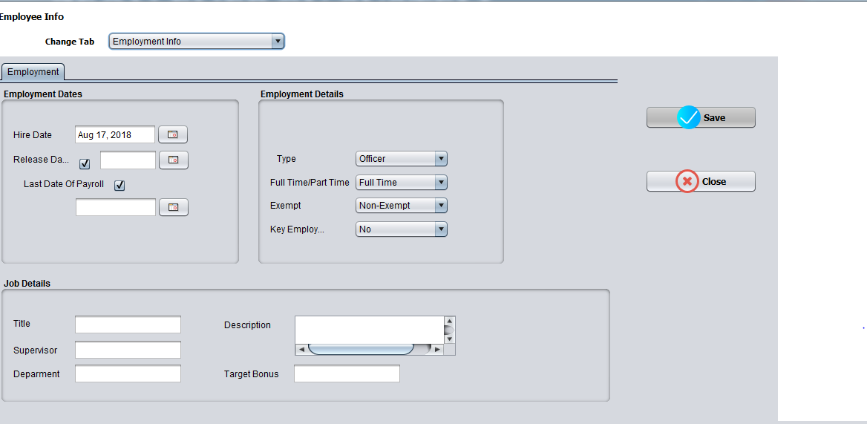

* User should enter employee’s employment dates , employment details and job details here .
* Finally click the save button .
* Data will auto update by the system .
* User can close this form whenever click the close button .
* Use should enter correct details .
* **Make Journal**

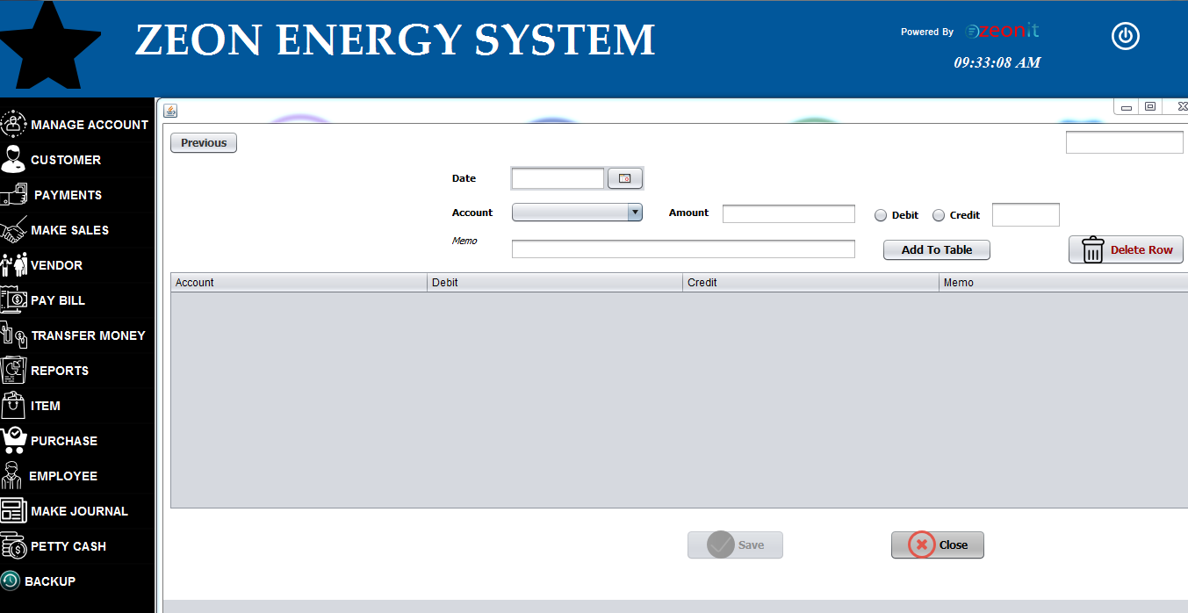

* This is the make journal form .
* All details should enter about the journal by the user .
* User should select card type in above check boxes .
* If you add incorrect data into the system , you should delete it in below table .
* If you enter all details , save button will auto enable by system .
* **Petty Cash**

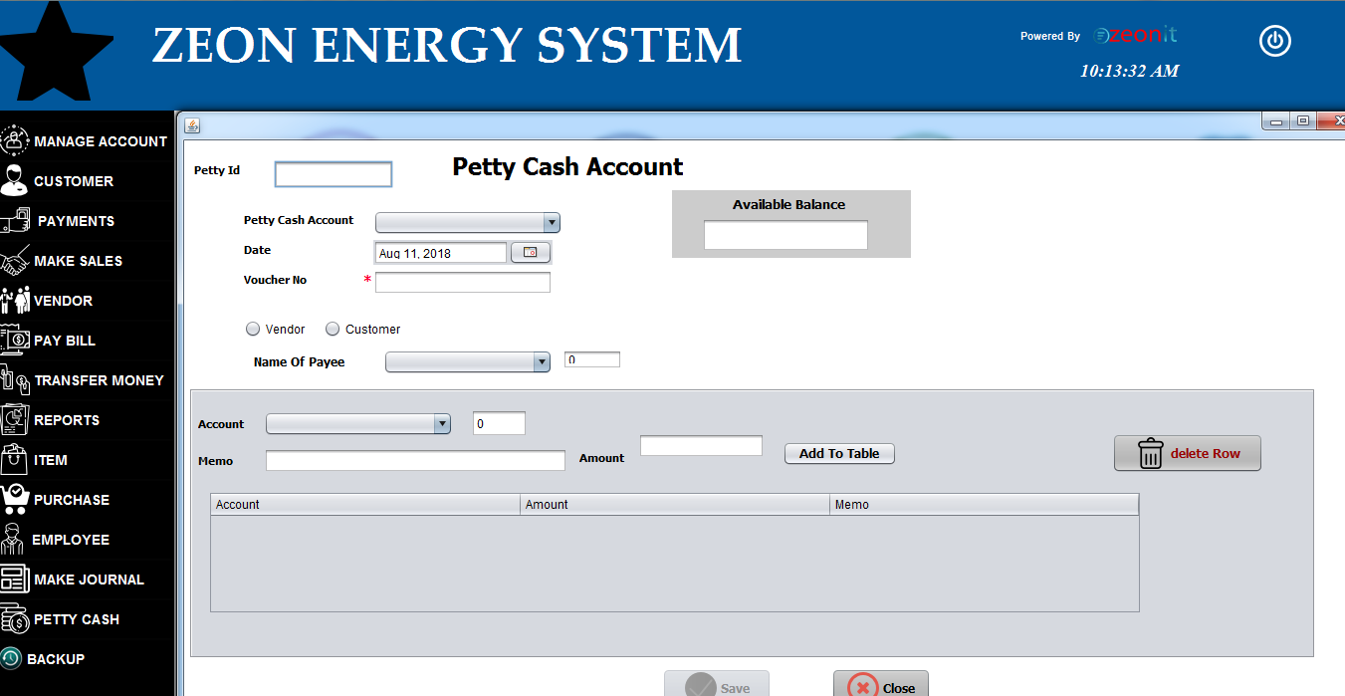

* This is petty cash form .
* Petty cash accounts will auto load to the combo box by the system .
* available balance show above in the Available balance blank text field .
* name of payee will auto loading by the system .
* Accounts will auto loading to the account combo box by the system .
* User should enter the data correctly into the text fields .
* After fill the details into the text field , please click the add to table button .
* User should select customers' type in above checkbox .
* If all data enter , please click the save button .
* If you entered data was incorrect , you can remove that data after select and click the delete row button .
* User can close this form click the close button .
* **Reports**

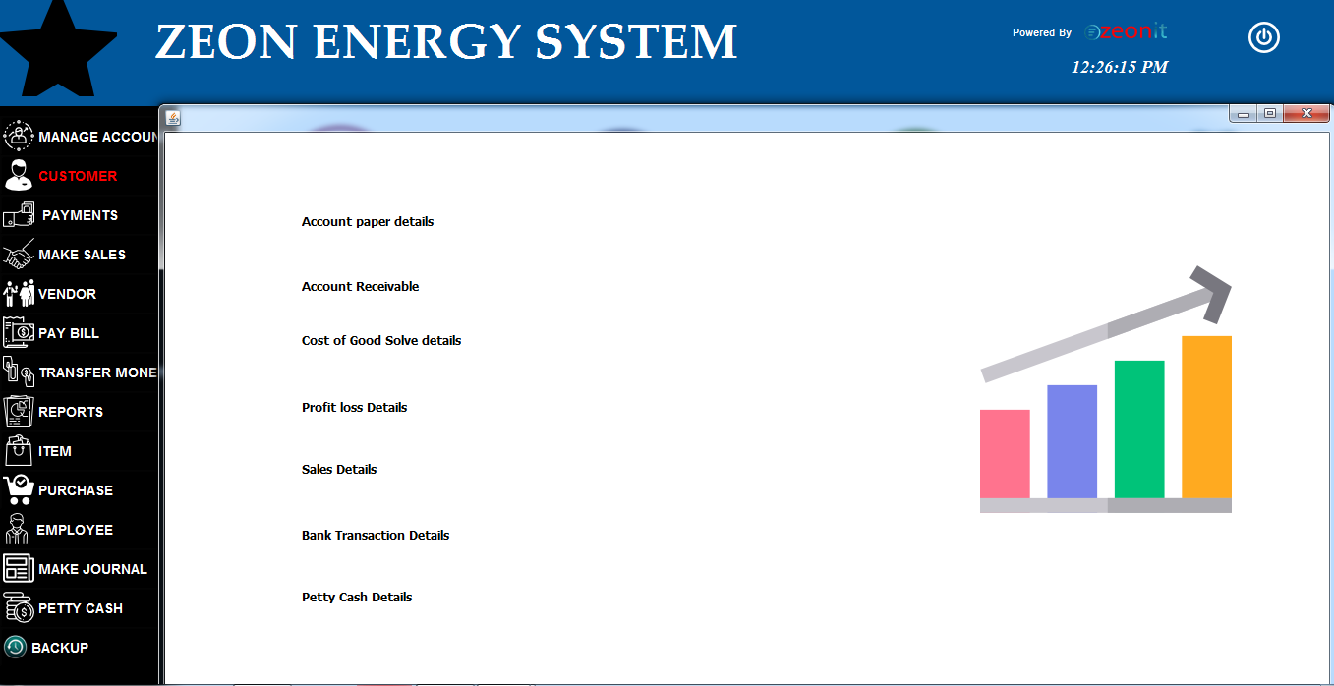

* User can get reports about Account Paper details ,Account Receivable details ,cost of good solve details , profit loss details , sales details ,Bank transaction details , petty cash details.
* You can see Account Paper detail report in below .

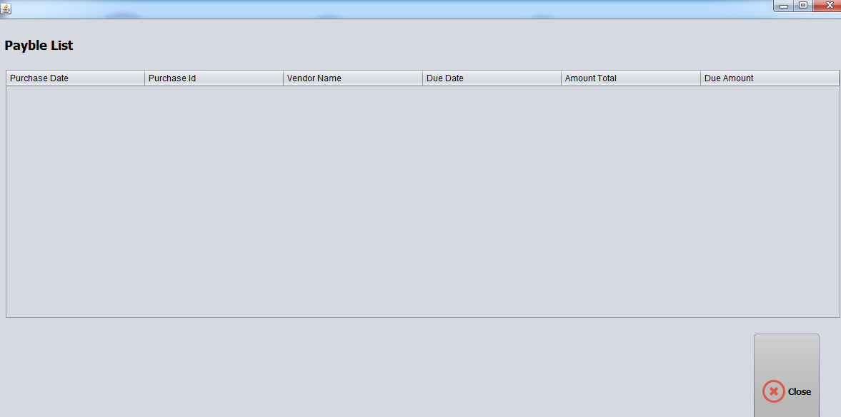

* Account Receivable report.

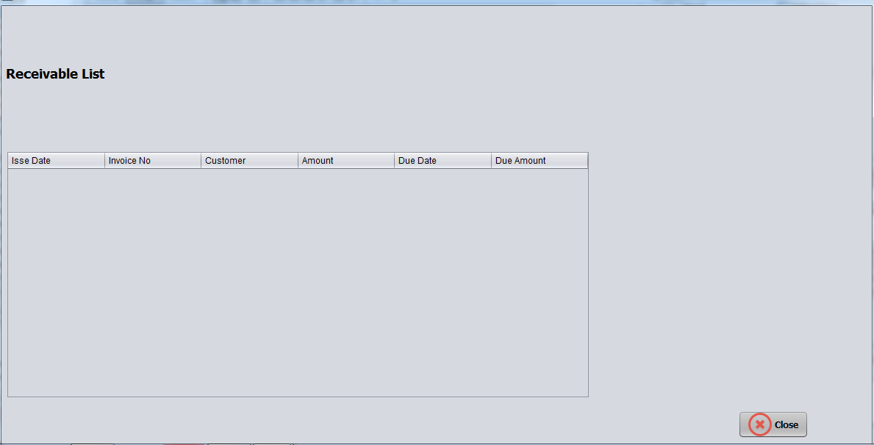

* Cost of good solve report .

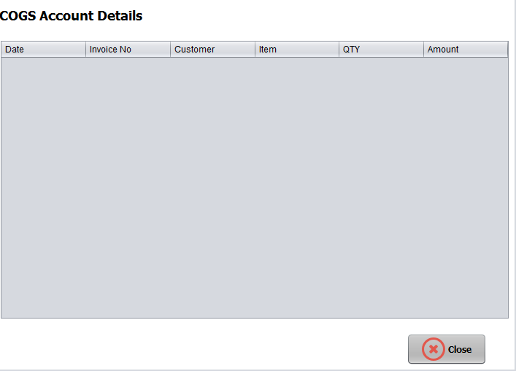

* Profit loss detail report .

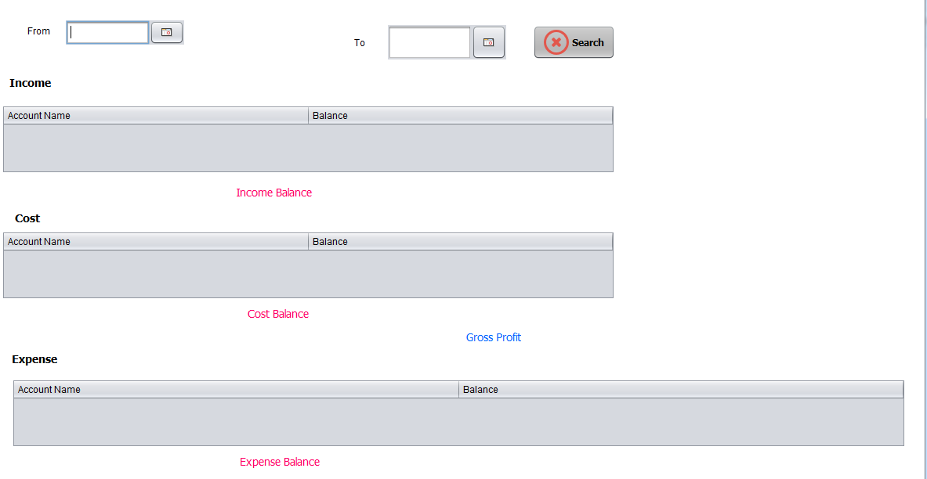

* Sales details Report .

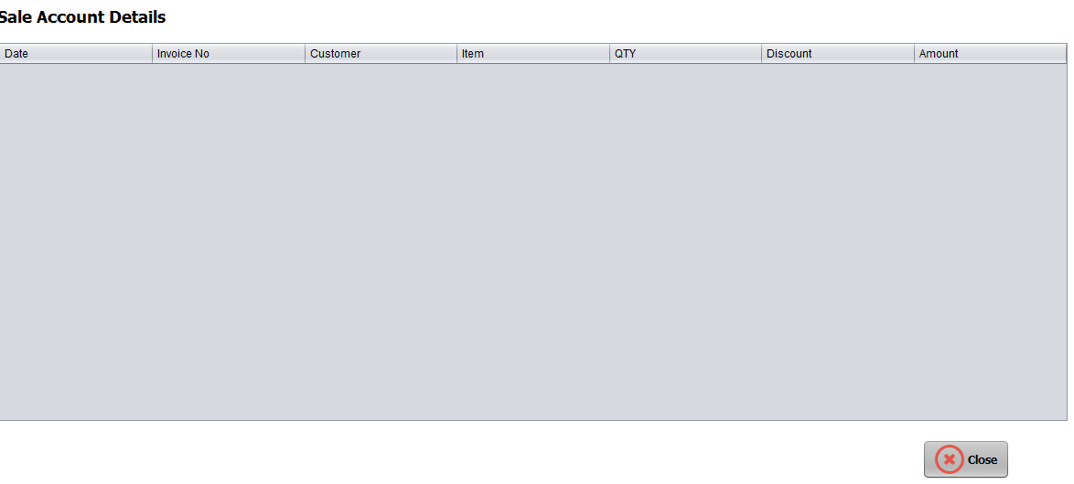

* Bank Transaction detail report .

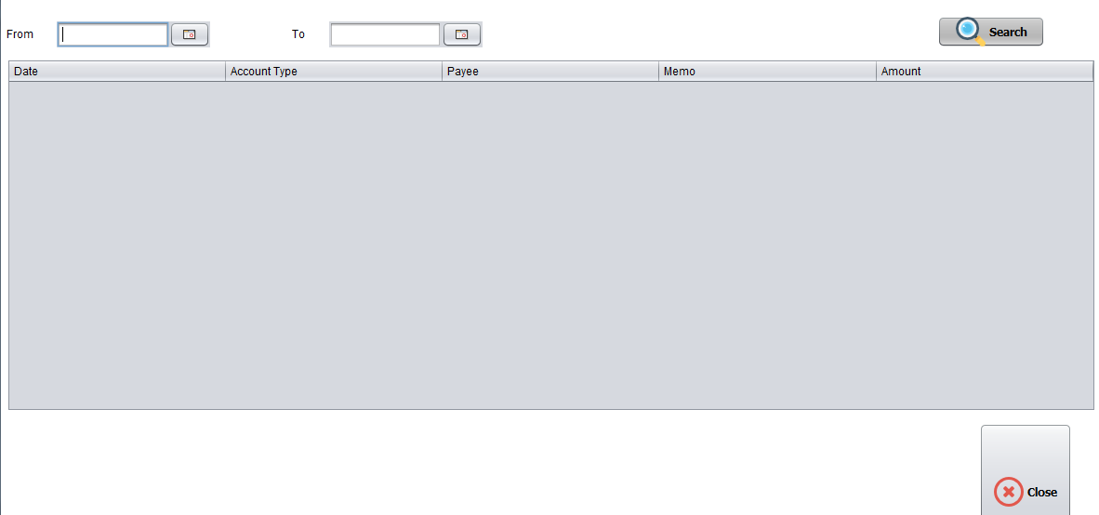

* Petty Cash details report .

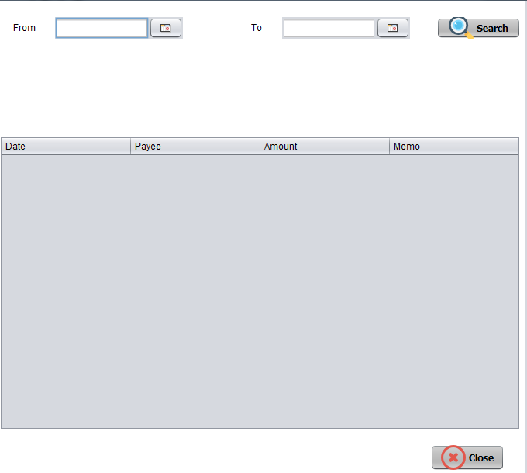

* **Backup**

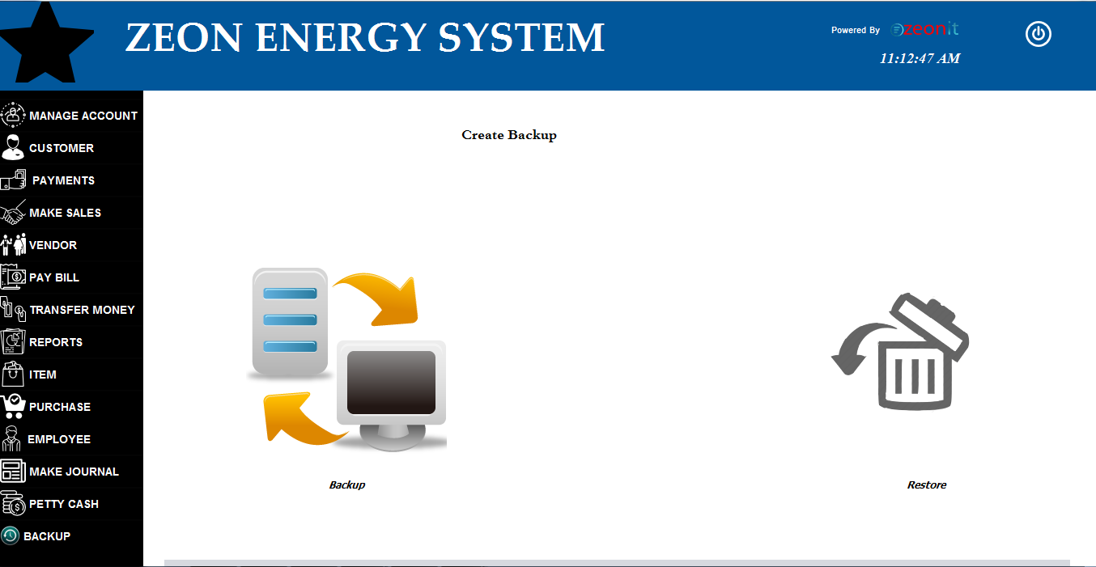

* This is Backup form .
* User can create backup using this form .

